However, the work of the committee is not yet done. The Friends of the Ruins Committee must now shoulder the cost of maintaining the edifice. As the structure is exposed to yearly harsh elements, it requires ongoing reappointing work, to maintain the stability of the structure. The committee is forever grateful to the donors who made the first step a reality. They now must appeal for continued assistance as they carry on the work of looking after this National Historic Site for generations to come.
Donations
Your charitable donations will help the Friends of the Ruins. Donations can be made by bequests, pledges, direct deposit (etransfers) or cheques made out to Friends of the Ruins St. Raphaels Inc. A charitable receipt will be mailed to you.
Direct deposits to:
saintraphaelsruins@gmail.com

Please send donations to:
Friends of the Ruins St. Raphael’s Inc.
P.O. Box 190,
Williamstown, Ontario
K0C 2J0
Donations of $1,000 or more, including in memoriam requests, will be noted on a plaque erected on the church walls.

Join us for our Annual Msgr. McDougald Tartan Golf Tournament, the Thursday preceding the Glengarry Highland Games.
For Information email:
Info@saintraphaels.com
Friends of the Ruins Saint Raphaels Inc.

www.saintraphaelsruins.com

The Heart
Of
Glengarry

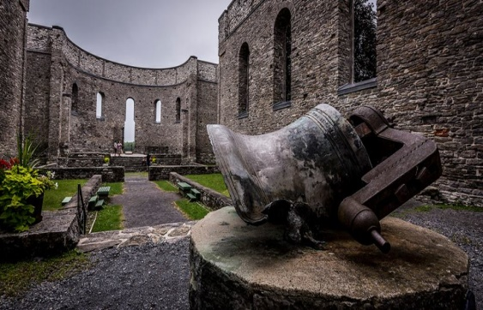

Across the Heart of Glengarry some miles inland from the St. Lawrence, the historic Kings’s Road runs east and west along the highlands. This high road, named for King George III, is an inverted riverbed left behind by a decaying glacier. Its broad sloped back has lelf aboriginal moccasins, borne the cannons of war, and witnessed the rise of a nation…
From the edge of old Quebec, crossing over the Military Road at Sandfield’s Corners (the “Brown House”) and through Indian Lands on the western boundary of Glengarry, the King’s Road runs past one of the most imposing historic structures in Eastern Canada. Begun on the eve of Waterloo, the majestic walls of the church of St. Raphaels overlook the green fields below.
These silent walls proclaim the dignity of our ancestors. The harmony of the place is that of Highland People: gentle in peace, fearsome in battle.
But why here? And what matter of men and women were these settlers of St. Raphaels.
They were the sons and daughters of the clans who were defeated with Bonnie Price Charlie at Culloden, of the loyal Scots from the Mohawk Valley of New York, and of the Glengarry Fencibiles of the Irish Rebellion of 1798 and of those who rallied to the fiery cross in the war of 1812.
Regrettably, the great St. Raphaels’ Church burned in August 1970 leaving only the majestic walls remaining. The night immortalized in song by Rob and Irene Taylor and recorded by the Brigadoons say it all.
The Burning of St. Raphaels
An August night some years ago
Most of the glen was sleeping;
The word went around, “Come fight the blaze,
St. Raphael’s church is burning”.
Into the sky the flames short forth
As all looked on astounded
And noiselessly the three bells fell
No death knell had been sounded.

They did their best to stop the fire
That started without warning;
With saddened hearts, they knew they’d failed
Come that grim August morning.
A century and a half it stood,
Renowned for age and beauty;
Its grand interior quickly lost
To fire, that fearsome enemy

No alter for His Holy cup;
No pews to seat His children;
Just cold and grey the walls of stone
Reach up to God’s own Heaven.
No stained glass windows for His house
That once was proud and glorious
But still it stands, a monument
To those who came before us.

In 1994, a committee called the Friends of St. Raphaels Ruins was formed with the determination to stabilize the walls that were sorely in need of repair. By 2005, through matching heritage grants, fund raising and generous donations from loyal supporters, the committee met their goal after raising over $1.400, 000.
With the stabilization complete the stately Ruins will remain for those who love the heritage and the beauty of the architecture.
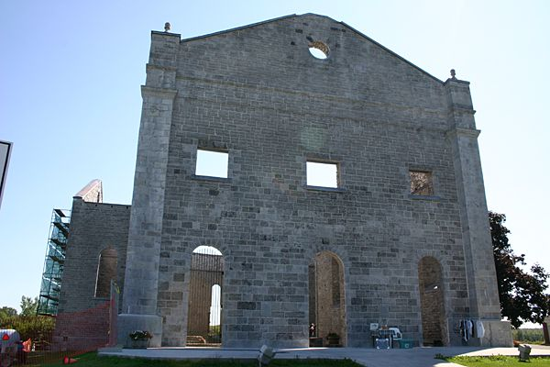
Over the years the Ruins has been a popular place for young couples to get married. It is also a very popular spot for professional photographers and holding concerts. The funds received from these events all help in our fundraising goals.
